A

Project Report on

CORE MODULE 1

** Server, DSL Modem, Cloud Configuration on Cisco Packet Tracer**

Submitted in partial fulfillment of completion of the course

**Advanced Diploma in IT, Networking and Cloud Computing**

Submitted by:

Aashika Raj

Susma Kumari Singh

Archana Kumari

Under Guidance of:

**<Arpita Roy > (Edunet)**

**  **

Abstract

Acknowledgement

Team Composition and Workload Division

Table of Contents

1. Introduction to Problem
2. Proposed Solution
3. Requirements

3.1 Technology Stack

3.2 Hardware

3.3 Software

3.4 Deployment Environment

. Design Documentation

6. Implementation Details

7. Testing

8. Deployment

9. Future Scope

10. Conclusion

Appendix A Screenshot of Project

References

**Abstract**

This abstract outlines the process of setting up a computer lab using Cisco Packet Tracer, a simulation tool designed for network and system modeling. The lab design encompasses network architecture, hardware configuration, and software setup to create a comprehensive learning environment.

The process involves several key steps:

**Network Topology Design:** Designing the network topology is the foundation of the computer lab. Determine the number of computers, switches, routers,DSL modem and other networking devices required. Organize the devices logically to ensure smooth connectivity and data flow.

**Device Configuration:** Configure the devices within the Packet Tracer environment. Assign appropriate IP addresses to computers.

**Switch Configuration:** Configure switches to enable VLANs and inter-VLAN routing. Implementing VLANs helps manage broadcast domains, enhancing network performance and security.

**Server Setup:** Set up virtual servers on computers within the lab. Install operating systems, configure services such as DHCP, DNS, and web servers, and create user accounts to mimic real-world scenarios.

**Testing and Optimization:** Thoroughly test the lab environment to identify potential issues and bottlenecks. Optimize configurations and address any performance concerns to ensure a seamless learning experience.

**Acknowledgement**

Team ‘FireFlies’ (consists of 3 members, namely Aashika Raj , Susma kumari Singh and Archana Kumari) are thankful to our trainer , Ms. Arpita Roy for their guidance , supervision and support which has provided a lot of resources needed in completing our project.

We are also thankful to the efforts put by our every individual team members and contributions to the completion of this project.

First and foremost, we want to thank my project supervisors, Arpita Roy(Edunet) for their guidance, expertise, and unwavering support. Their insights and feedback have been instrumental in shaping the direction of this project.

We would also like to extend my appreciation to my fellow classmates who provided valuable input, shared resources, and engaged in stimulating discussions that enriched the project. Your collaborative spirit was a driving force behind our achievements.

Last but not least, we are grateful to the entire faculty and staff of NSTI Kolkata for providing a conducive learning environment and the necessary resources to undertake this project.

This project has been a rewarding learning experience, and we are thankful for the collective efforts of everyone involved. Your support has been instrumental in making this project a reality.

Thank you all for being a part of this journey.

Aashika Raj, Susma Kumari singh, Archana Kumari

NSTI KOLKATA

04/09/2023

**Team Composition and Workload Division**

Our team comprises of three members namely

1. Aashika Raj
2. Susma Kumari Singh
3. Archana Kumari

**Aashika Raj**: Project planning , Desiging the system set up and documentations .

**Susma Kumari Singh**: Design and configuration of the virtual network infrastructure in Cisco Packet Tracer.

**Archana Kumari**: Testing and Simulaion panal and Troubleshooting , documentation.

**Table of Contents**

**Introduction to Problem**

Cisco Packet Tracer is a tool built by Cisco and it provides network simulation to practice simple and complex networks. The main purpose of the Cisco Packet Tracer is to help students learn the principles of networking and demonstrate the networking concepts. A DHCP Server is a network server that automatically assigns IP addresses, default gateways, and other network parameters to client devices.

**Proposed Solution**

Proposing a solution for creating computer labs in Packet Tracer involves outlining a systematic approach to designing and implementing effective network simulations for educational purposes. Here's a proposed solution:

1. **Define Educational Objectives:**

Begin by clearly defining the educational goals and learning outcomes you want to achieve with the computer lab. What specific networking concepts or skills do you want students to grasp through this lab?

2. **Select Appropriate Network Topology:**

Based on the defined objectives, choose a network topology that aligns with the learning goals. Consider factors like complexity, scalability, and relevance to the course.

4. **Design Network Components:**

Create a list of network components required for the lab, including routers, switches, PCs, servers, and other relevant devices. Determine the number and configuration of each component.

4. **Configure Devices:**

Configure each network device in Packet Tracer according to the lab's requirements. Ensure that configurations reflect real-world scenarios and adhere to best practices.

5. **Develop Lab Scenarios:**

Design specific networking scenarios and exercises that align with the educational objectives. These could include tasks like configuring VLANs, setting up routing protocols, troubleshooting network issues, or simulating security attacks.

**Requirements**

**Technology Stack:** Networking

**Hardware:**

Processor: Intel(R) Core (TM) i5-9500 CPU @ 4.00GHz 4.00 GHz

Installed RAM 8.00 GB (7.81 GB usable)

System type 64-bit operating system, x64-based processor

**Software:** CISCO Packet Tracer

**Deployment Environment:** It is deployed in CISCO Packet Tracer

**User Requirements (Students)**

Creating a computer Server, DSL Modem, Cloud Configuration on cisco Packet Tracer involves simulating a network environment with multiple computers, networking equipment, and configurations.

If a user wants to use it then he/she requires some basic things like a working PC , an operating system , and a strong network connection.

These are the basic requirements of an user.

**Step 1:** Open the Cisco Packet Tracer.

**Step 2.:** After opening the Cisco Packet tracer, add a router, 2 switches, 6 PCs, 1 server, 2 DSL Modem and a Cloud to build a network for a Server, DSL Modem, Cloud Configuration organization.

|  |  |
| --- | --- |
| **Router** | 1 |
| **Switch** | 2 |
| **Server** | 1 |
| **PC** | 6 |
| **DSL Modem** | 1 |
| **Cloud** | 1 |

**Assume there’re four sections in this small organization**:

1. Administration section
2. Accounts and Finance
3. Information Technology (IT)
4. Database section.

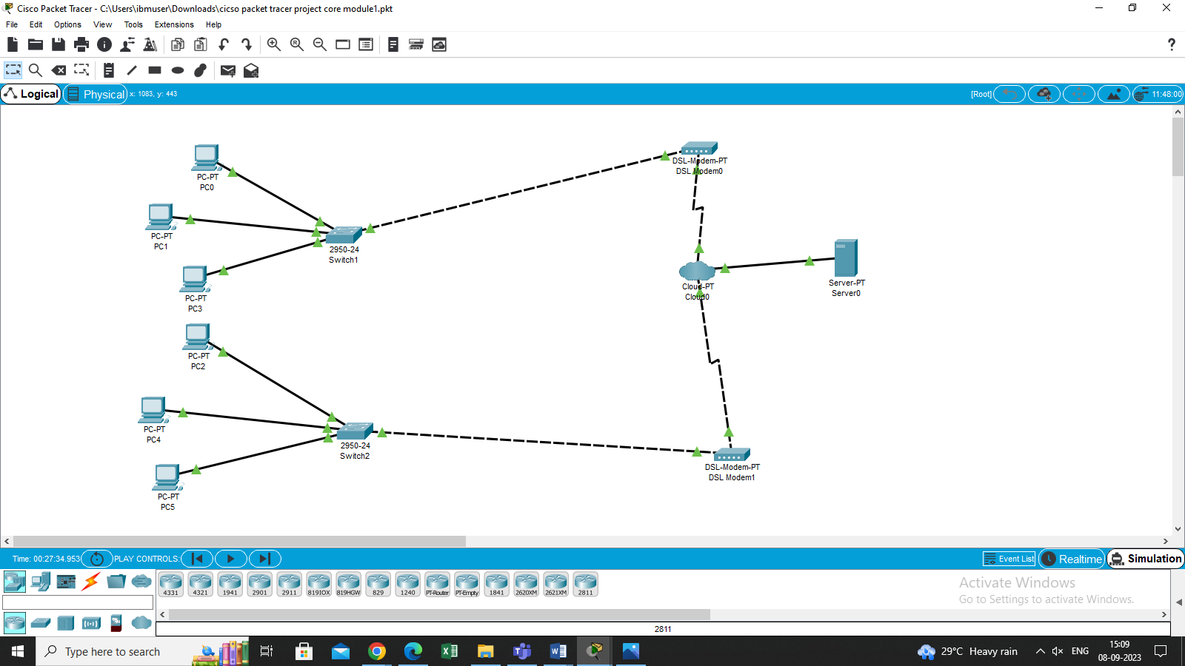

**Step 3:**Connect the 6 pc with 2 switches, 1 switches are connected with 3 PC each, and 1 switch is connected with the DSL-Modem and connect with server using a cloud-pt.

**Step 4:**Give IP, subnet mask, default gateway, and DNS server to each PC and server in this network. To assign IP to each PC and server, click on each PC, go to Desktop, and then click on IP configuration.

|  |  |  |  |  |
| --- | --- | --- | --- | --- |
| **Components** | **IP Address** | **Subnet Mask** | **Default Gateway** | **DNS server** |
| PC0 | 169.254.3.17 | 255.255.0.0 | 0.0.0.0 | 0.0.0.0 |
| PC1 | 169.254.18.16 | 255.255.0.0 | 0.0.0.0 | 0.0.0.0 |
| PC2 | 169.254. 138.53 | 255.255.0.0 | 0.0.0.0 | 0.0.0.0 |
| PC3 | 169.254. 173.90 | 255.255.0.0 | 0.0.0.0 | 0.0.0.0 |
| PC4 | 169.254.168.26 | 255.255.0.0 | 0.0.0.0 | 0.0.0.0 |
| PC5 | 169.254.108.235 | 255.255.0.0 | 0.0.0.0 | 0.0.0.0 |
| Server | 169.254.120.3 | 255.255.0.0 | 0.0.0.0 | 0.0.0.0 |

**Design Documentation:**

**Design Documentation**

Step 1: Open the Cisco Packet Tracer.

Step 2: After opening the CISCO packet tracer, add 2 switch, a server, 2 DSL modem and 6 PCs to the screen from the bottom left section for this project.

Step 4: Connect all PCs and the server with a switch by using a cable from the cable section.

Step 4: We’re considering the server as a DHCP server. Click on server, go to Desktop, and then click on IP configuration. Give an IP address, subnet mask, and default gateway to the server.

Step 5: Click again on the server, click on the services section, and then go to DHCP. Turn on the DHCP services and then enter the default gateway, starting IP address, subnet mask, and a number of devices, and then SAVE it. Now, the DHCP server will automatically assign IP, subnet mask, etc. to the PCs

Step 6: Click on any PC, go to Desktop, and then click on the IP configuration section. Click on DHCP and it will request the IP address, subnet mask, etc. from the DHCP server and it will automatically assign all these to the PC.

Step 7: Do this for all the PCs. One can also use the ping command to check the communication between all PCs.

**Testing**

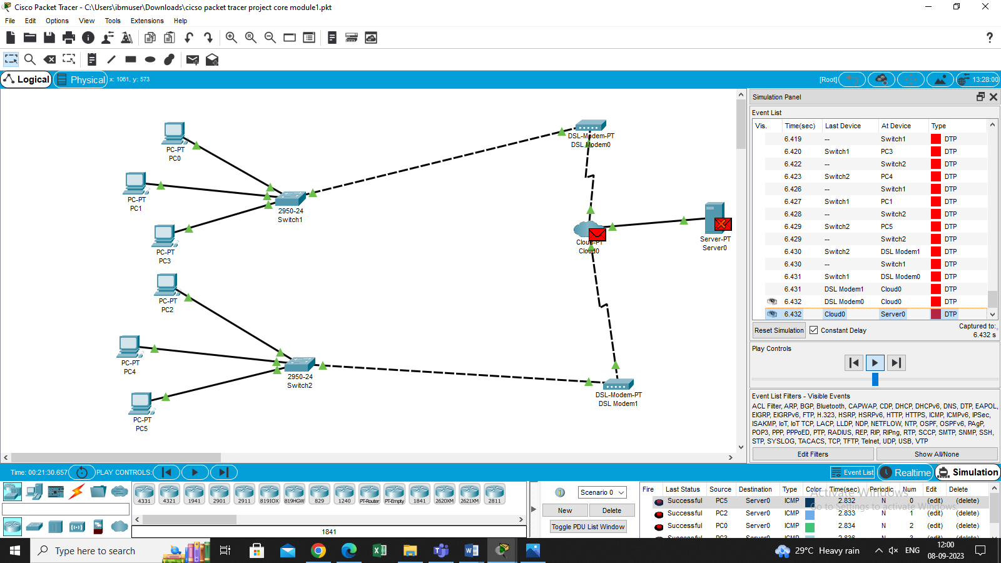



**Deployment**

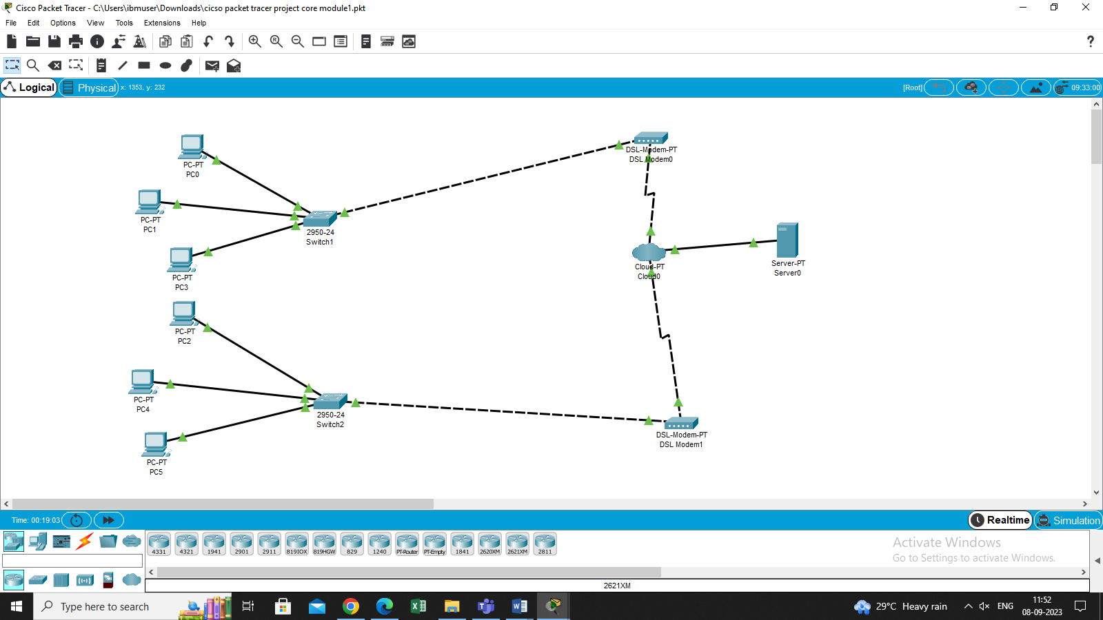

**Future Scope**

The future scope for Server, DSL Modem, Cloud Configuration on Cisco Packet Tracer is broad and can involve various enhancements and expansions to improve functionality, flexibility, and educational value. Cisco packet tracer is to expand the network and make it suitable for larger organizations Here are some potential areas for future development: We can add more switches, routers, and servers to the network to accommodate more devices and improve the network's scalability.

.

In addition, we can configure the network for other services such as VoIP, VPN, and cloud services. This will add more value to the network and make it suitable for a wide range of organizations with varying requirements.

Overall, the set up in Server, DSL Modem, Cloud Configuration on Cisco Packet Tracer is just the beginning, and the sky is the limit when it comes to network design and implementation. With the right skills and resources, we can create complex networks for businesses and organizations of all sizes.  So, it is very important to translate the configurations and protocols in proper English for effective communication and understanding.

**Conclusion**

Creating Tracer is a valuable and essential skill for anyone interested in networking and IT education. This project demonstrates the ability to design, configure, and manage virtual network environments, providing hands-on experience in a safe and controlled environment. In conclusion, through this project, we've learned how to design Network Topology , device configuration , subnetting and IP addressing , network services etc.In conclusion, creating Server, DSL Modem, Cloud Configuration on Cisco Packet tracer configuring a network topology consisting of a server, DSL modem, and cloud (representing the internet) in Cisco Packet Tracer.

**Appendix A Screenshot of Project**



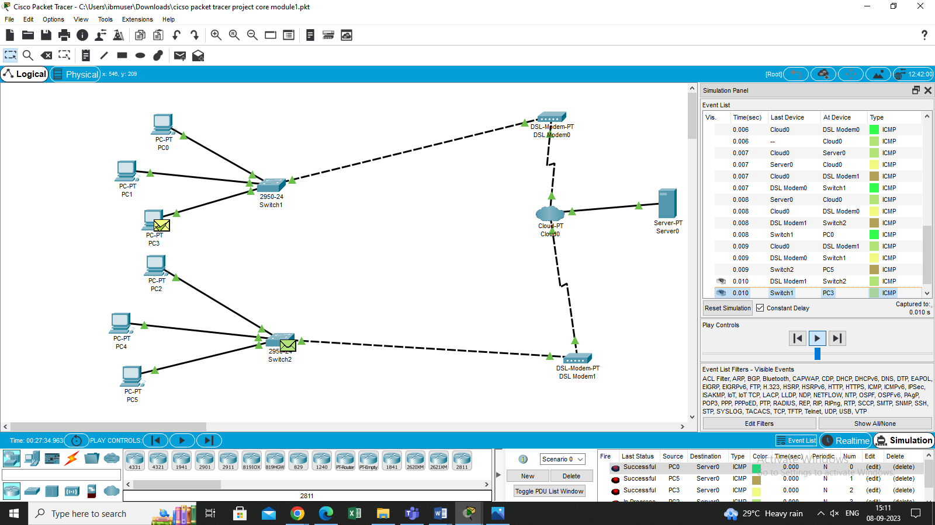

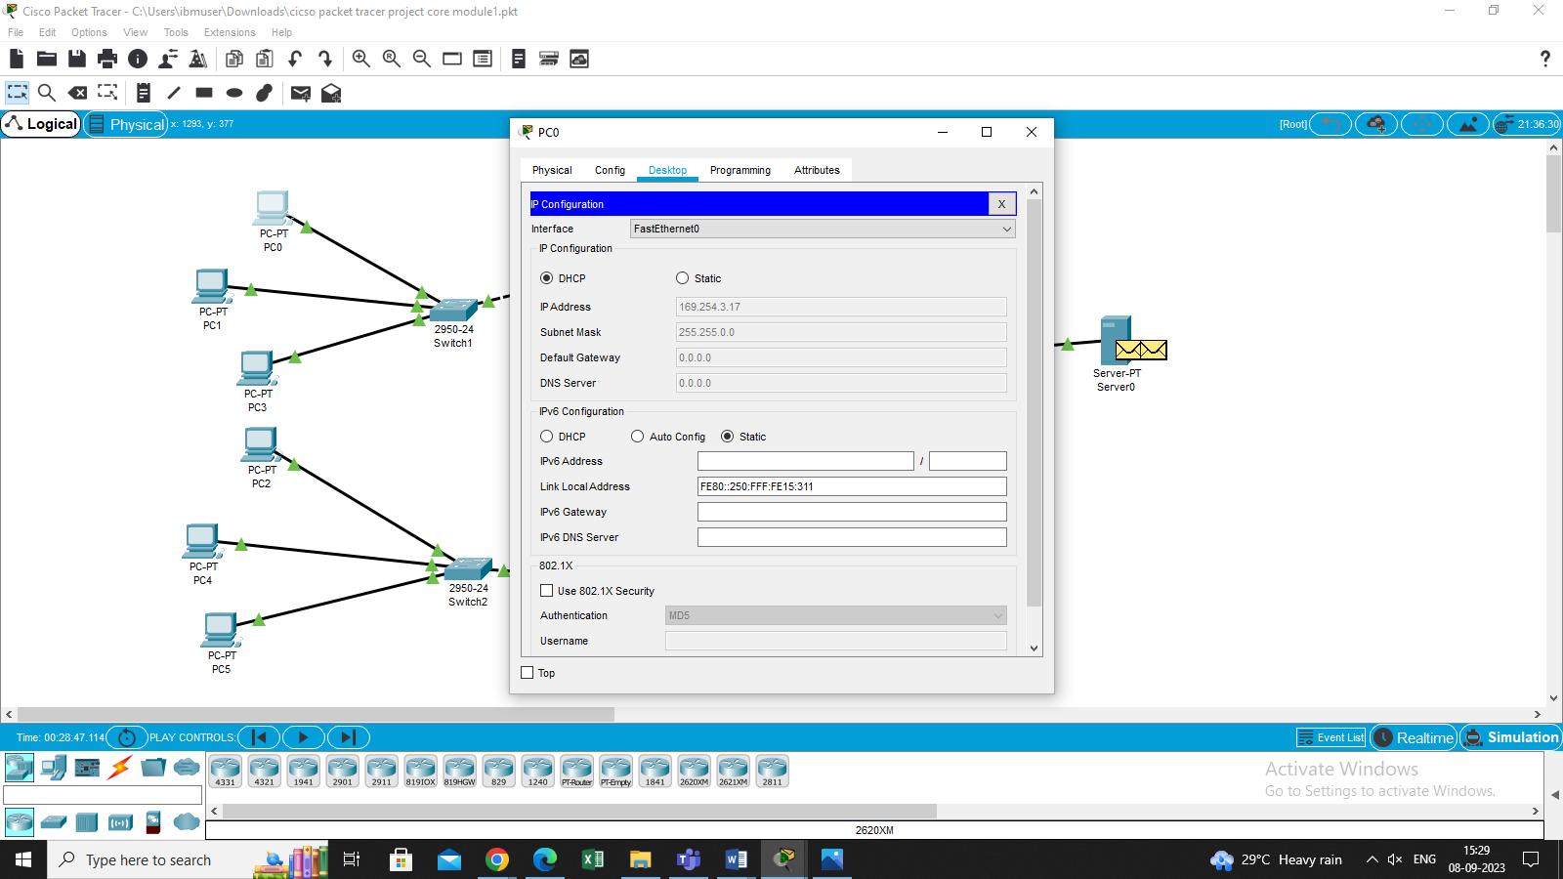

**References**

* <https://www.geeksforgeeks.org/how-to-make-computer-lab-in-packet-tracer/>
* <https://www.netacad.com/courses/packet-tracer>
* https://www.youtube.com/watch?v=JumX9bXUXak